Topic as per syllabus | As per Text Book
Memory management strategies: Background, Swapping, Contiguous  Memory Allocation, Segmentation, Paging, Structure of Page Table | Chapter 8 Main Memory  8.1 Background 351  8.2 Swapping 358  8.3 Contiguous Memory Allocation 360  8.4 Segmentation 364  8.5 Paging 366  8.6 Structure of the Page Table 378
Virtual Memory Management: Background, Demand paging, copy on write, Page replacement algorithms, Allocation of frames, Thrashing. | Chapter 9 Virtual Memory  9.1 Background 397  9.2 Demand Paging 401  9.3 Copy-on-Write 408  9.4 Page Replacement 409  9.5 Allocation of Frames 421  9.6 Thrashing 425

Section | What We Learn
9.1 Background | Understands the need for Virtual Memory, its advantages over traditional memory management, the concept of Virtual Address Space, and how logical memory is separated from physical memory. Also explains memory sharing through shared libraries and shared memory.
9.2 Demand Paging | Learns how pages are loaded into memory only when required instead of loading the entire process. Covers lazy loading, valid–invalid bits, page faults, page-fault handling, hardware support, and performance evaluation using Effective Access Time (EAT).
9.3 Copy-on-Write (COW) | Explains how parent and child processes can initially share memory pages after a fork() operation. Actual copying occurs only when a process modifies a page, reducing memory consumption and improving process creation efficiency.
9.4 Page Replacement | Studies what happens when a page fault occurs and no free frame is available. Explains how the operating system selects a victim page using algorithms such as FIFO, Optimal, LRU, LFU, and MFU to minimize page faults and improve memory utilization.
9.5 Allocation of Frames | Examines how available physical memory frames are distributed among processes. Covers minimum frame requirements, equal/proportional/priority allocation methods, global vs local allocation policies, and NUMA-based memory allocation strategies.
9.6 Thrashing | Understands the condition where excessive page faults cause the CPU to spend more time swapping pages than executing processes. Explains causes of thrashing and prevention techniques using Locality of Reference, Working-Set Model, and Page-Fault Frequency (PFF) methods.

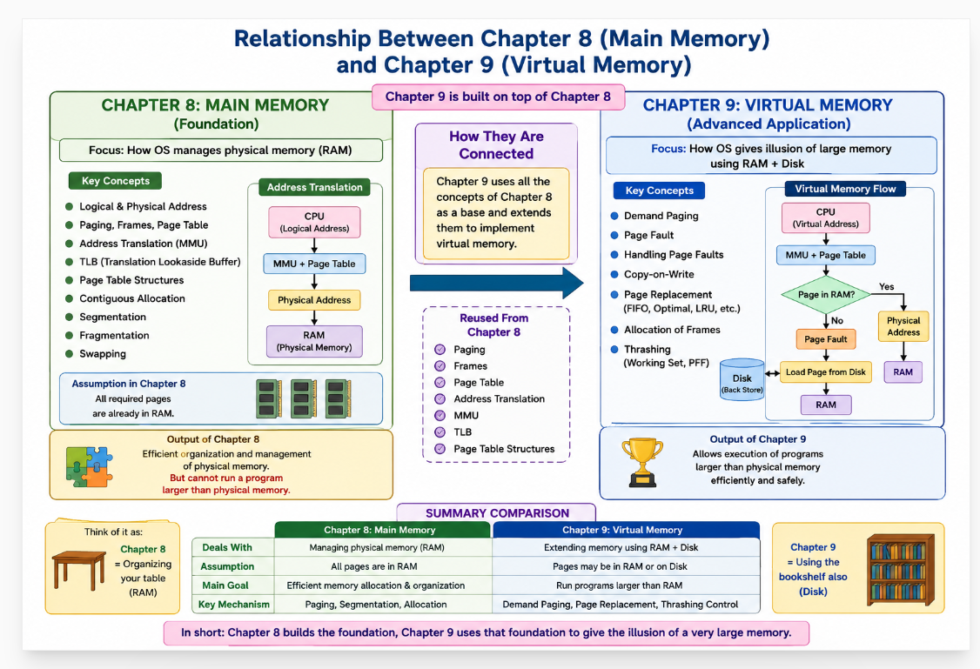

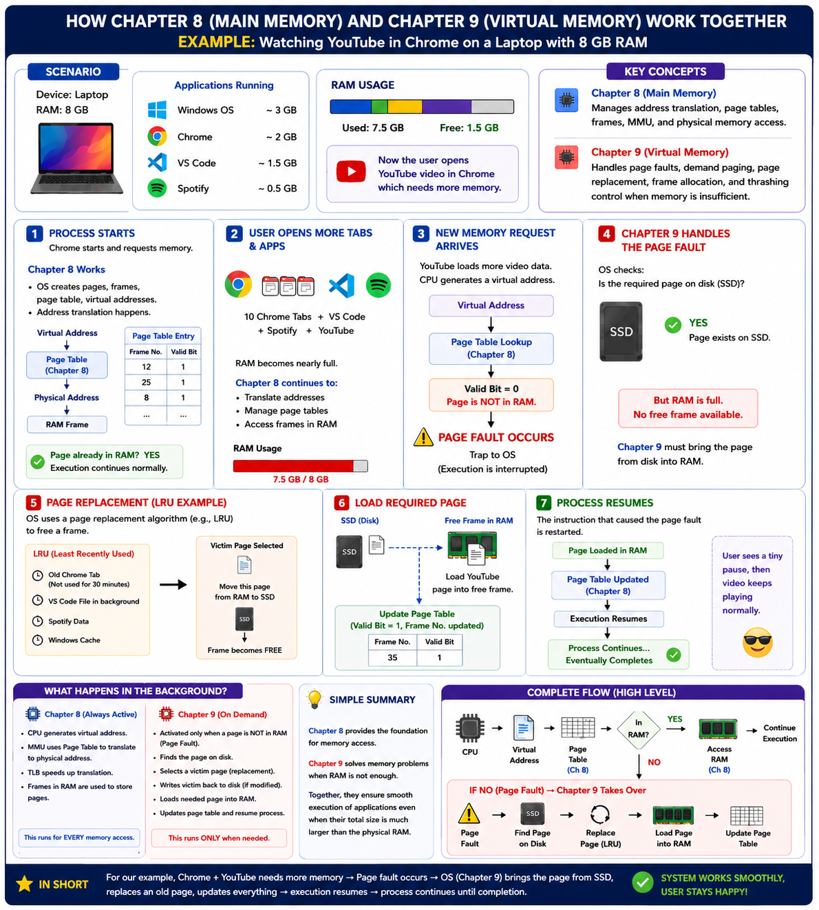

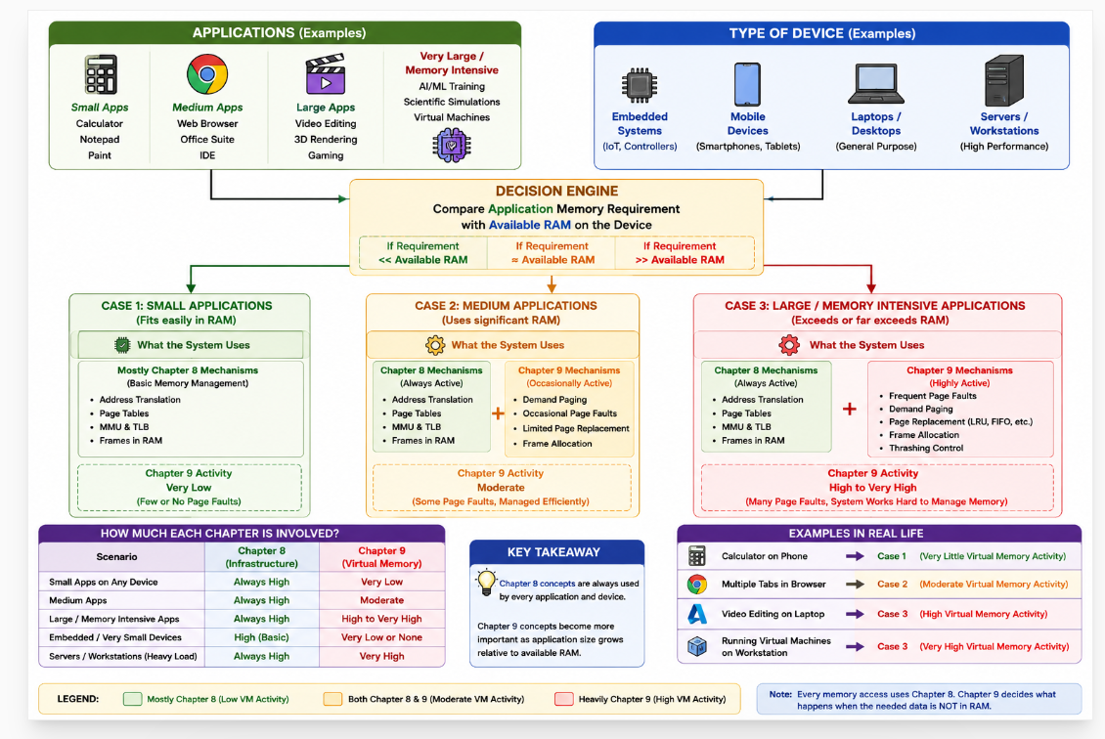

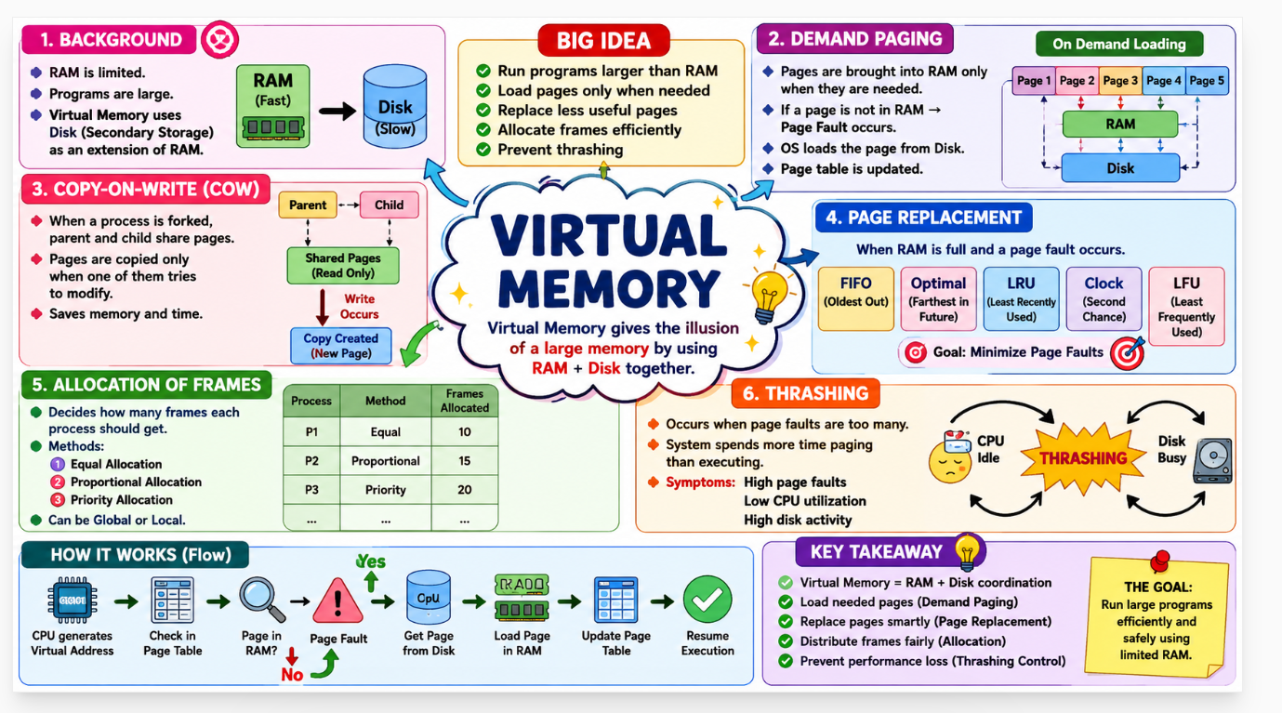
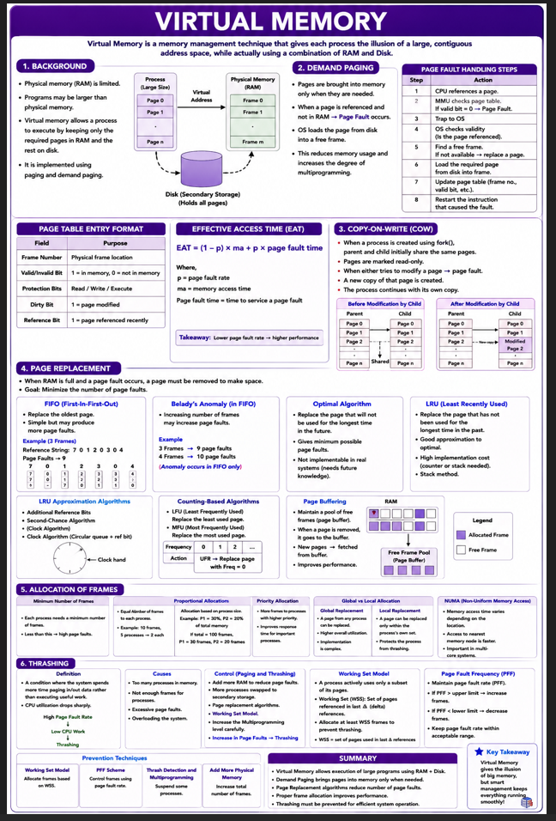

The Virtual Memory chapter teaches how an operating system gives processes the illusion of a large memory, loads pages only when needed, replaces pages intelligently when memory is full, allocates memory efficiently among processes, and prevents performance degradation caused by excessive paging (thrashing).
Section | Topic | Brief Explanation
9.1 | Background | Introduces the concept of virtual memory and why it is needed in modern operating systems.
9.1.1 | Why Virtual Memory | Explains the limitations of physical memory and the need for larger logical memory spaces.
9.1.2 | Virtual Address Space | Describes the logical address range seen by a process independent of physical memory size.
9.1.3 | Address Translation | Explains how virtual addresses are converted into physical addresses using page tables and MMU.
9.1.4 | Benefits of Virtual Memory | Discusses advantages such as larger address space, improved multiprogramming, and memory protection.

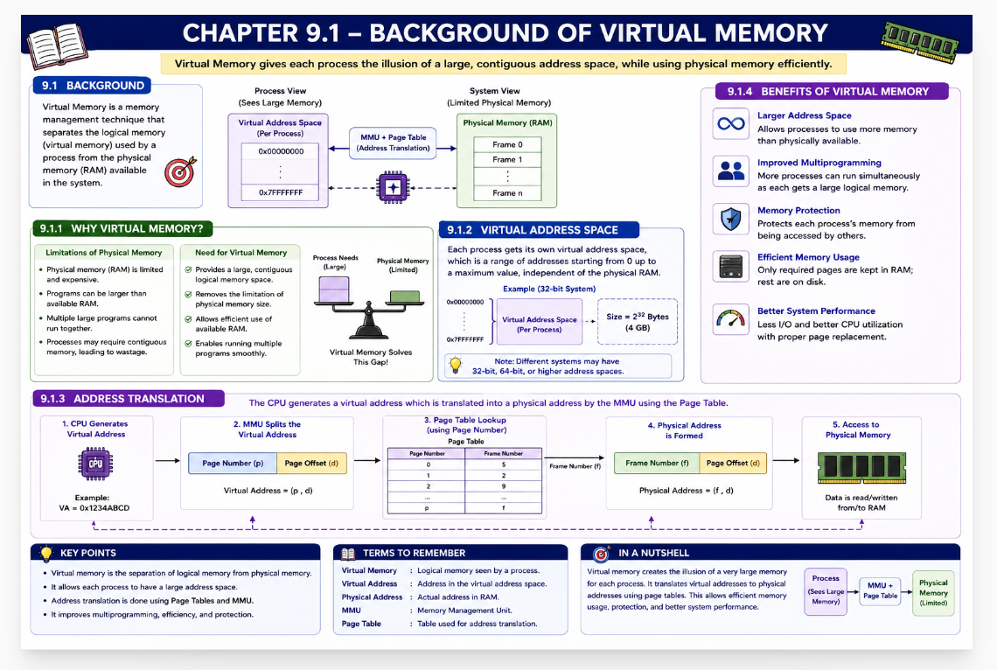

9.1 Background
Virtual memory's flexibility in memory allocation and process communication, through techniques like page sharing and memory mapping, provides significant efficiency gains. By implementing virtual memory with demand paging, the system can load only the required parts of a program into memory, reducing both the memory footprint and the time spent loading programs. The following sections will explore the implementation of virtual memory through demand paging and its associated benefits.
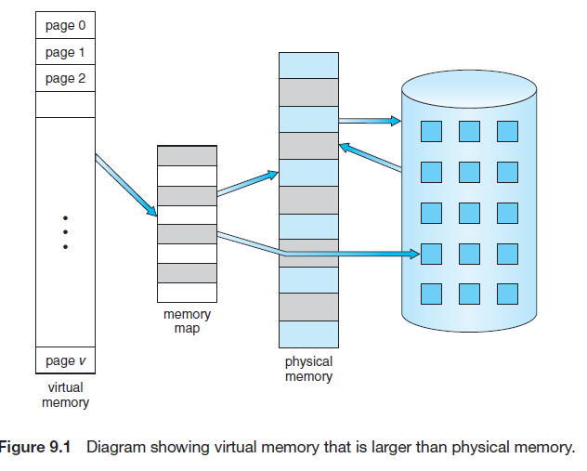
Figure 9.1 illustrates that virtual memory can be much larger than the available physical memory. The operating system maintains a large logical address space for each process while only the required pages are stored in RAM. This separation of logical memory from physical memory allows programs larger than RAM to execute efficiently. As a result, programmers can focus on application development without worrying about physical memory limitations.

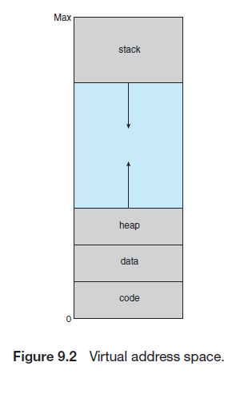
Figure 9.2 illustrates the virtual address space of a process consisting of Code, Data, Heap, Hole, and Stack segments. The heap grows upward for dynamic memory allocation, while the stack grows downward during function calls. The unused space between them provides flexibility for future memory expansion and is known as a sparse address space
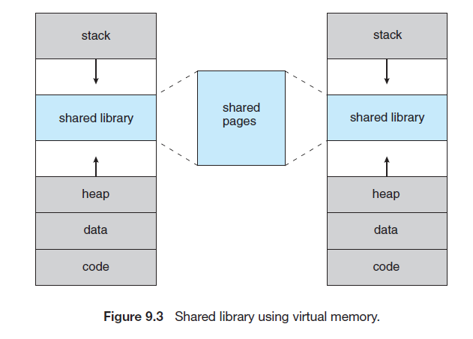

Figure 9.3 illustrates how virtual memory enables page sharing among multiple processes. Although each process has its own virtual address space, certain pages can be shared in physical memory, reducing memory usage and improving efficiency.
Shared libraries, shared memory regions, and pages created during process creation can be mapped into multiple virtual address spaces while referring to the same physical pages. This reduces memory usage, improves performance, and enables efficient process communication.
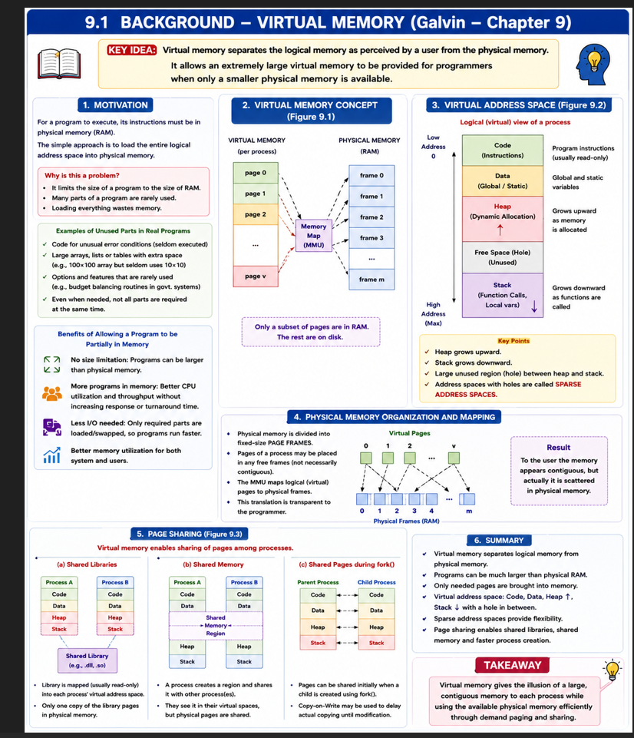

9.2 Demand Paging
Section | Topic | Brief Explanation
9.2 | Demand Paging | A virtual memory technique that loads pages into memory only when they are required during execution.
9.2.1 | Basic Concepts | Introduces demand paging, lazy loading, pager, valid–invalid bit, page faults, and page-fault handling. Only required pages are brought into RAM while unused pages remain on disk.
9.2.2 | Performance of Demand Paging | Evaluates the efficiency of demand paging using Effective Access Time (EAT) and page-fault rate. Performance depends on the frequency and cost of servicing page faults.

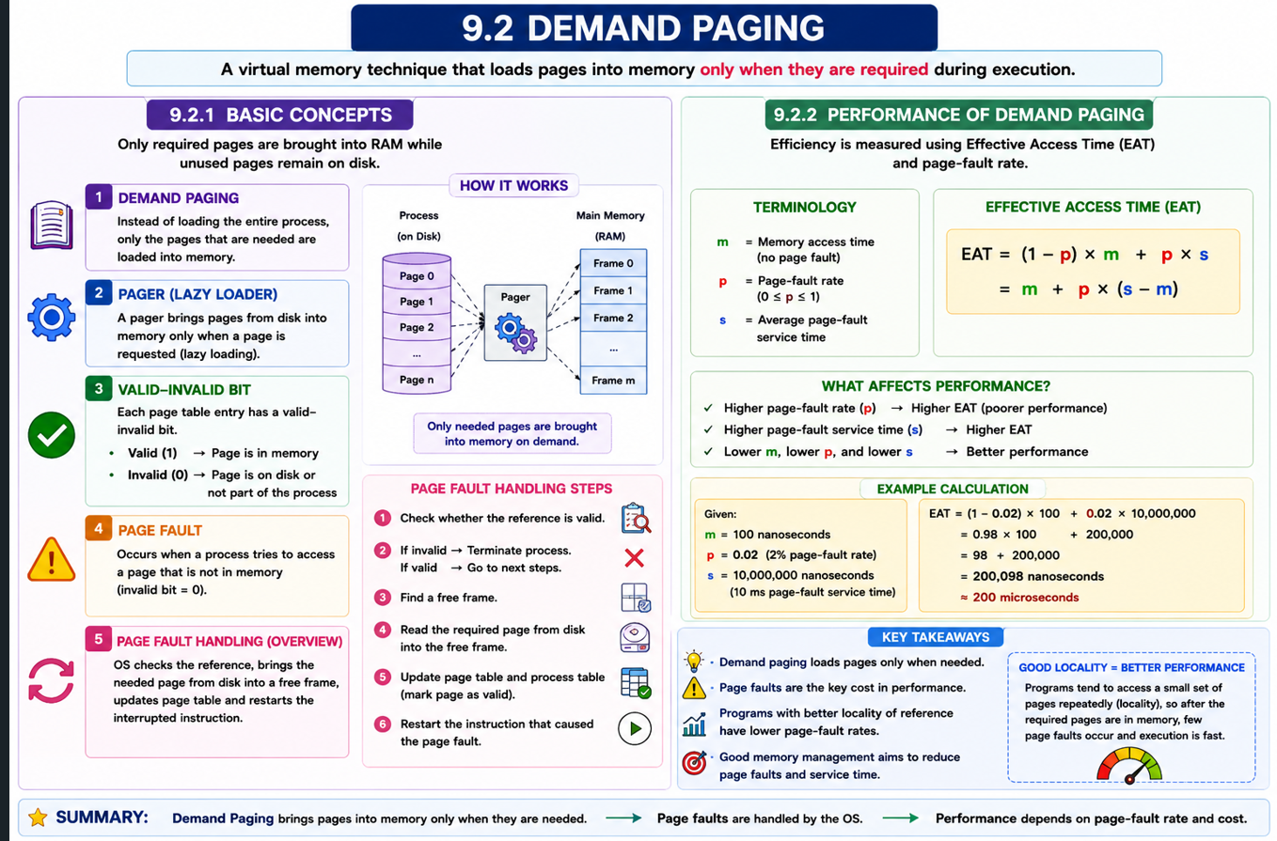

9.2.1 Basic Concepts
Demand Paging is a virtual memory technique in which pages are loaded into physical memory only when they are needed during program execution. Instead of loading the entire program into RAM, only the required pages are brought into memory, while the remaining pages stay on disk. This reduces memory usage and improves efficiency.
As shown in Figure 9.4, processes initially reside in secondary storage, and pages are transferred to RAM only when requested by the CPU. Demand paging follows a lazy loading approach, meaning pages are loaded only on demand.
In a demand-paging system, a pager is responsible for loading individual pages into memory. This differs from a swapper, which transfers an entire process between disk and memory.
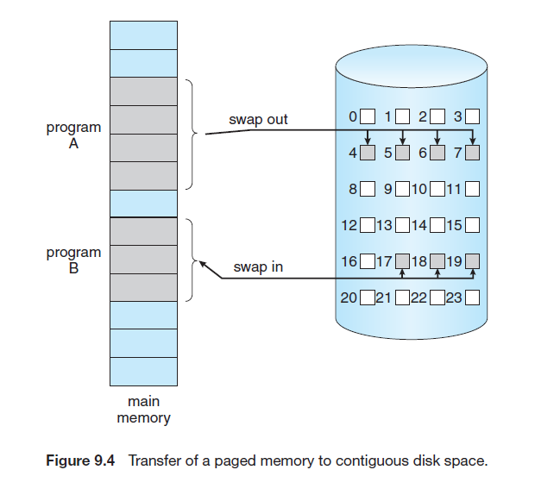
9.2.1 Basic Concepts
In a demand-paging system, the operating system must identify whether a page is currently present in memory or stored on disk. Figure 9.5 uses a Valid–Invalid Bit in each page-table entry for this purpose.
- Valid (V = 1): The page is legal and currently present in physical memory.
- Invalid (V = 0): The page is either not part of the process's address space or is currently stored on disk.
When the pager loads a page into memory, its page-table entry is marked valid. Pages that are not in memory are marked invalid (or may contain their disk location). If a process accesses a valid page, execution continues normally. If it accesses an invalid page that is actually on disk, a page fault occurs, and the operating system loads the required page into memory.
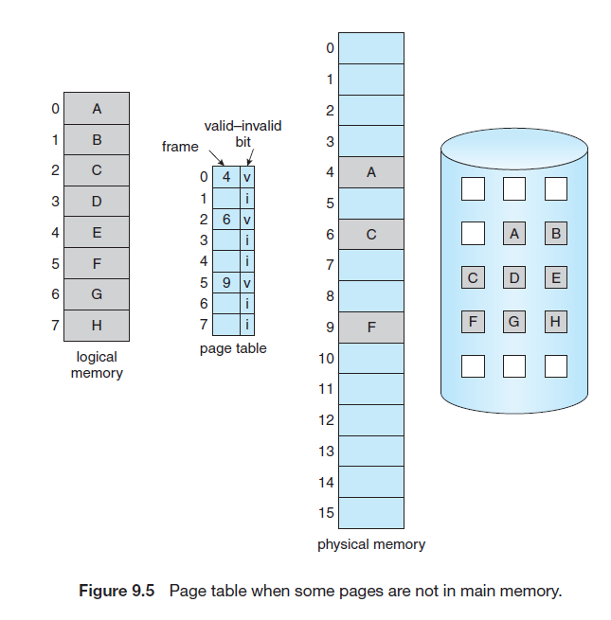

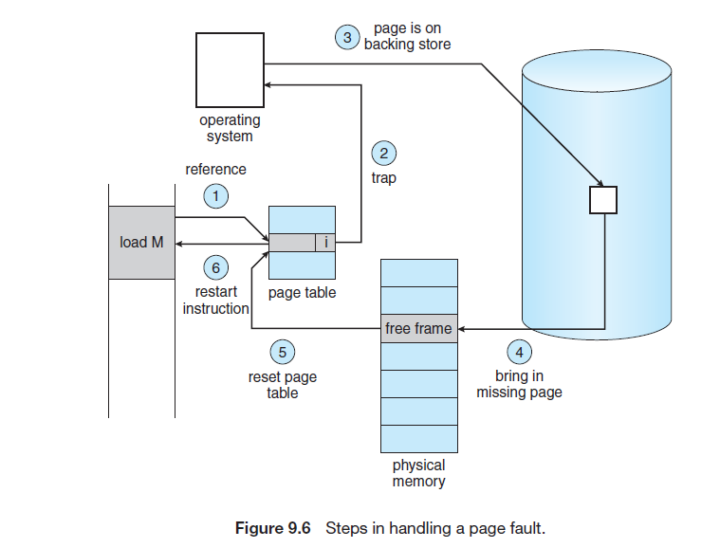
A page fault occurs when a process tries to access a page that is not currently present in physical memory. The paging hardware checks the page table and finds that the valid–invalid bit is set to invalid, causing a trap to the operating system. The OS then takes appropriate action to bring the required page into memory.

Steps in Handling a Page Fault (Figure 9.6)

Step 1: Check Memory Reference
The operating system checks the process's internal table (PCB) to determine whether the memory reference is valid or invalid.

Step 2: Validate the Access
- If the reference is invalid, the process is terminated.
- If the reference is valid but the page is not in memory, the OS proceeds to load the page.

Step 3: Find a Free Frame
The operating system locates a free frame from the free-frame list.

Step 4: Read Page from Disk
A disk operation is scheduled to transfer the required page from secondary storage (disk) into the selected free frame.

Step 5: Update Page Tables
After the page is loaded, the operating system updates:
- Page Table
- Internal Process Table
The page is now marked as valid and present in memory.

Step 6: Restart Execution
The interrupted instruction is restarted, and the process continues execution as if the page had always been in memory.
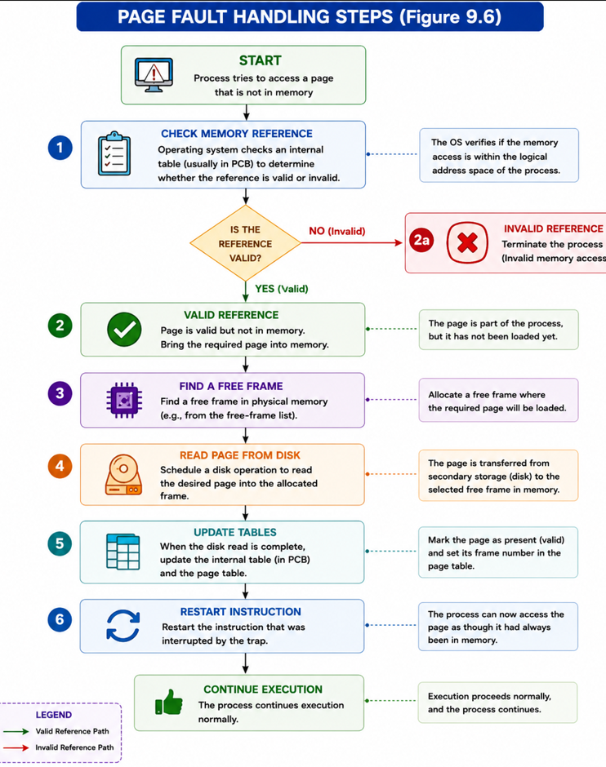
In Pure Demand Paging, a process may start execution with no pages loaded in memory. As execution proceeds, pages are brought into memory only when they are first referenced. This approach ensures that only required pages occupy RAM, leading to efficient memory utilization.
Demand paging works efficiently because programs generally exhibit locality of reference, meaning they tend to access the same set of pages repeatedly. Therefore, after the required pages are loaded, page faults become less frequent and execution proceeds smoothly.
9.2.2 Performance of Demand Paging
The performance of demand paging depends on the page-fault rate. Since page-fault service time is much larger than memory-access time, even a small increase in page faults can drastically increase Effective Access Time (EAT). Therefore, operating systems must maintain a very low page-fault rate to achieve efficient execution.
Demand paging improves memory utilization by loading pages only when they are needed. However, its performance depends on how often page faults occur. If a required page is already in memory, access is very fast and equal to the normal memory-access time. When a page fault occurs, the operating system must bring the required page from disk into memory before execution can continue. Since disk access is much slower than memory access, page faults can significantly affect system performance.
To evaluate the performance of a demand-paging system, we use Effective Access Time (EAT). Let ma represent the memory-access time and p represent the probability of a page fault. The effective access time is given by
This equation shows that the average memory access time depends on both normal memory accesses and page-fault service time.
When a page fault occurs, the operating system performs several activities. It traps to the operating system, saves the process state, determines that the interrupt is a page fault, verifies the legality of the memory reference, locates the page on disk, reads the page into a free frame, updates the page table, restores the process state, and restarts the interrupted instruction. These operations contribute to the page-fault service time.
The page-fault service time consists of three major components:
- Service the page-fault interrupt
- Read the required page from disk
- Restart the interrupted process
The first and third operations generally take only a few microseconds. However, disk access is very expensive. A typical hard disk may require:
- Average latency = 3 ms
- Seek time = 5 ms
- Transfer time = 0.05 ms
Thus, the total page-fault service time is approximately 8 milliseconds. Since disk access dominates the service time, page faults are costly operations.
Consider a system with:
- Memory Access Time = 200 nanoseconds
- Page Fault Service Time = 8 milliseconds
The Effective Access Time becomes:
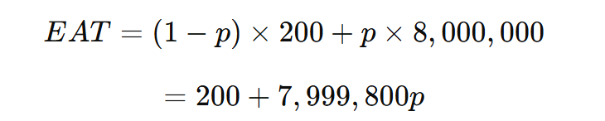
This equation shows that the effective access time is directly proportional to the page-fault rate (p). As the probability of page faults increases, the average memory access time increases dramatically.
For example, if only 1 memory access out of 1,000 causes a page fault:
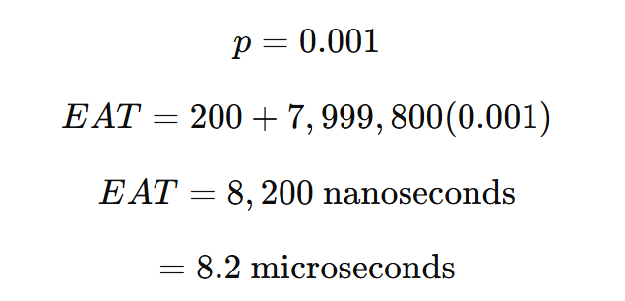
In this case, the system becomes approximately 40 times slower than normal memory access. This example demonstrates how even a small page-fault rate can severely degrade performance.
To limit performance degradation to less than 10%, the effective access time should not exceed:
$$220\text{ nanoseconds}$$
Therefore,
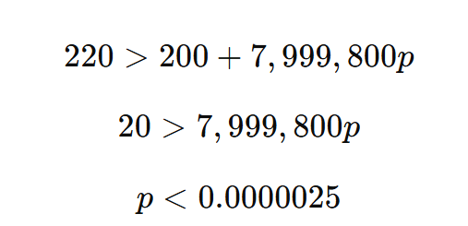\
This means that fewer than 1 memory access out of 399,990 accesses should result in a page fault. Hence, operating systems must keep the page-fault rate extremely low to maintain good performance.
Another important aspect of demand paging is swap space. Pages that are not currently in memory are stored in swap space on disk. Since swap space is optimized for paging operations, accessing it is generally faster than accessing ordinary files. Some operating systems initially load pages from the file system and later move modified pages to swap space for more efficient paging.
Modern mobile operating systems generally avoid traditional swapping. Instead, they reclaim unused read-only pages and reload them from the file system when required. This approach reduces storage overhead while still supporting demand paging.
The performance of demand paging depends on the page-fault rate. Since page-fault service time is much larger than memory-access time, even a small increase in page faults can drastically increase Effective Access Time (EAT). Therefore, operating systems must maintain a very low page-fault rate to achieve efficient execution.

9.3 Copy-on-Write

Section | Topic | Brief Explanation
9.3 | Copy-on-Write (COW) | Optimization technique that delays copying pages until modification is required.
9.3.1 | Motivation | Reduces unnecessary memory duplication during process creation.
9.3.2 | Basic Idea | Parent and child initially share pages after a fork operation.
9.3.3 | Steps in Copy-on-Write | A copy of a page is created only when one process attempts to modify it.
9.3.4 | Advantages | Saves memory, reduces overhead, and improves process creation speed.
9.3.5 | Applications | Used in UNIX fork(), virtual machines, and shared libraries.

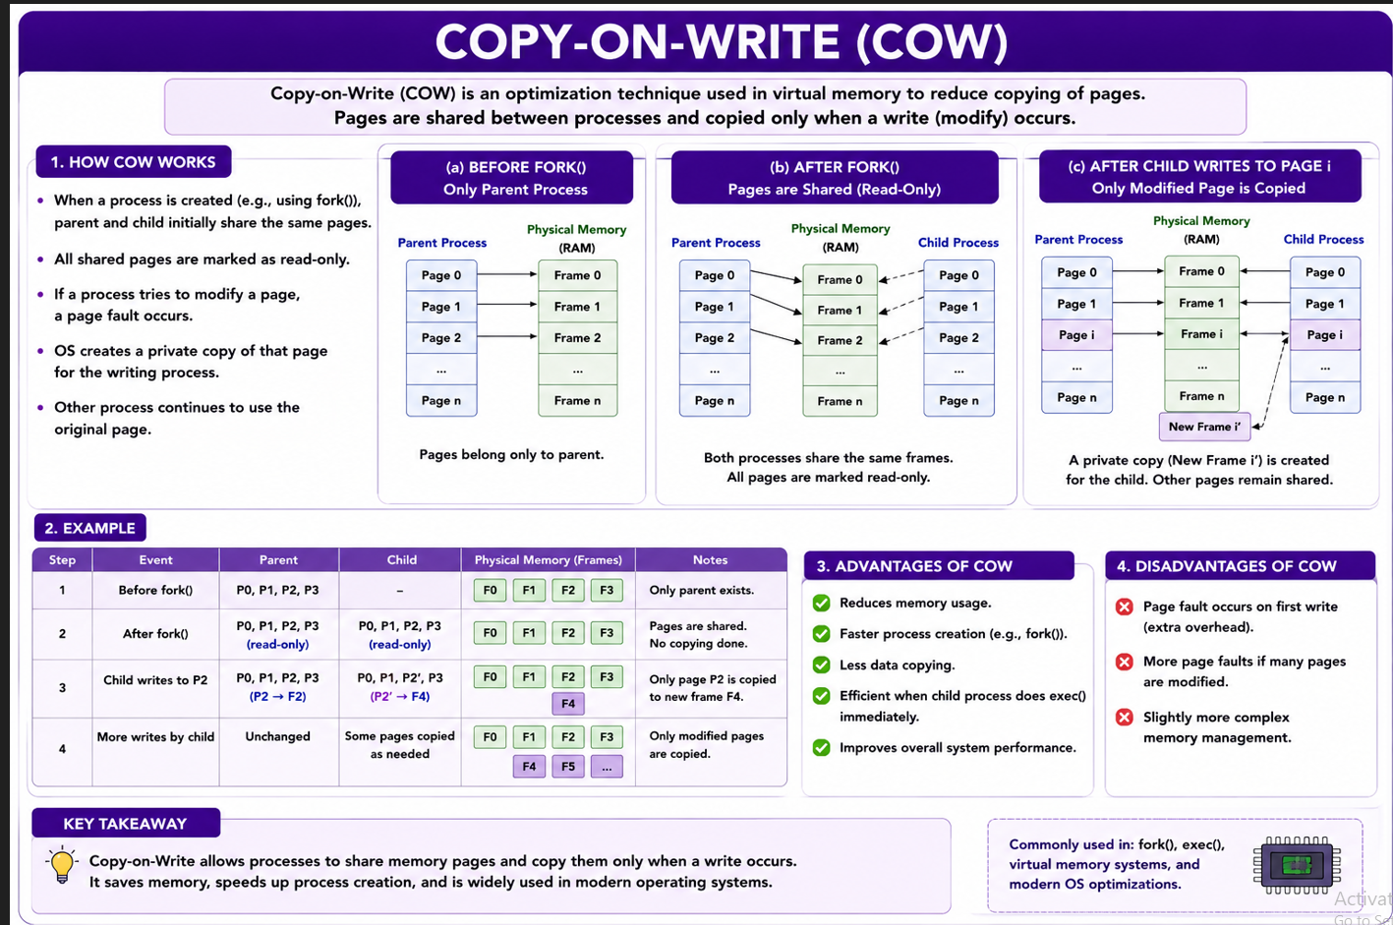
9.3 Copy-on-Write

Introduction
When a process is created using the fork() system call, the child process is initially a duplicate of its parent. Traditionally, this duplication required copying the entire address space of the parent process into the child process. However, in many cases the child immediately executes an exec() system call, replacing its address space with a new program. Therefore, copying all the pages of the parent process becomes unnecessary and wastes both memory and time.
To overcome this problem, operating systems use a technique called Copy-on-Write (COW). This technique improves process creation speed and reduces memory consumption by delaying page copying until it is actually required.

Basic Idea of Copy-on-Write
In Copy-on-Write, the parent and child processes initially share the same physical pages after a fork() operation. These shared pages are marked as Copy-on-Write pages.
As long as both processes only read the pages, no copying occurs. If either the parent or child attempts to modify a shared page, the operating system creates a separate copy of that page and assigns it to the process making the modification. Thus, page copying occurs only when a write operation takes place.
This approach significantly reduces unnecessary duplication of memory pages.

Working of Copy-on-Write (Figures 9.7 and 9.8)
Figure 9.7 shows the situation immediately after a fork() operation. Both Process 1 and Process 2 share the same physical pages (A, B, and C).
Process 1 ──► Page A
► Page B
► Page C
Process 2 ──► Page A
► Page B
► Page C
No additional memory is allocated because the pages are shared.
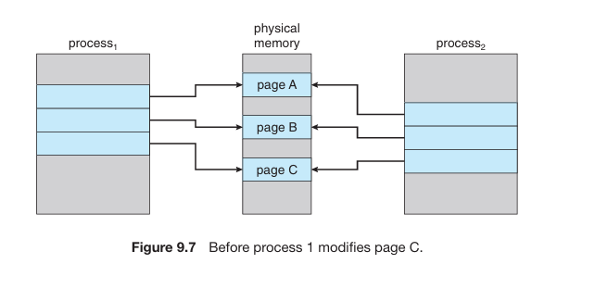
Figure 9.8 shows what happens when Process 1 attempts to modify Page C. Since Page C is marked as Copy-on-Write, the operating system creates a new copy of Page C and assigns it to Process 1.
Process 1 ──► Copy of Page C
Process 2 ──► Original Page C
Only the modified page is copied, while the remaining pages continue to be shared.

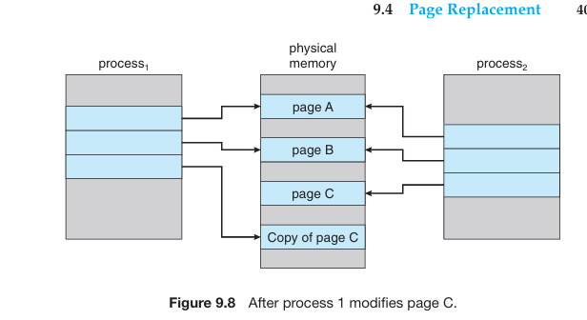

Advantages of Copy-on-Write
Copy-on-Write provides several important benefits:
- Reduces memory usage by sharing pages.
- Speeds up process creation because pages are not copied immediately.
- Reduces CPU overhead during fork().
- Copies only pages that are actually modified.
- Improves overall system performance.
Because of these advantages, Copy-on-Write is widely used in modern operating systems such as Linux, Windows, and Solaris.

Sharing of Read-Only Pages
Not all pages require Copy-on-Write protection.
Pages containing:
- Executable code
- System libraries
- Read-only data
cannot be modified and therefore can be permanently shared between parent and child processes without creating additional copies.
This further reduces memory consumption.

Free Page Allocation and Zero-Fill-on-Demand
When the operating system needs to create a new copy of a page, it allocates a free page from a pool of available memory pages.
These pages are often allocated using a technique called Zero-Fill-on-Demand.
In this technique:
- The page is cleared before allocation.
- All contents are set to zero.
- Previous data is removed.
This improves security and ensures that a process does not accidentally access data belonging to another process.

vfork() System Call
Many UNIX systems provide a special version of fork() called vfork() (Virtual Memory Fork).
Unlike fork() with Copy-on-Write:
- The child process directly uses the parent's address space.
- No page copying occurs.
- The parent process is suspended until the child completes or executes exec().
Since no pages are copied, vfork() is extremely fast and efficient.
However, it must be used carefully because if the child modifies memory, those changes become visible to the parent process when it resumes execution.
Copy-on-Write (COW) is a memory optimization technique in which parent and child processes initially share the same memory pages after a fork(). A page is copied only when one of the processes attempts to modify it, reducing memory usage and speeding up process creation.

9.4 Page Replacement
Section | Topic | Brief Explanation
9.4 | Page Replacement | A memory-management technique used when a page fault occurs and no free frame is available. The operating system must select a page to remove from memory to make room for the required page.
9.4.1 | Basic Page Replacement | Explains the general page-replacement process: page fault occurs → select victim page → remove victim page → load required page → update page table → resume execution.
9.4.2 | FIFO Page Replacement | First-In First-Out algorithm replaces the page that has been in memory the longest (the oldest page). Simple to implement but may suffer from Belady’s Anomaly.
9.4.3 | Optimal Page Replacement | Replaces the page that will not be used for the longest time in the future. Produces the minimum possible page faults and serves as a benchmark for comparison.
9.4.4 | LRU Page Replacement | Least Recently Used algorithm replaces the page that has not been used for the longest period in the past. Based on the principle of locality of reference.

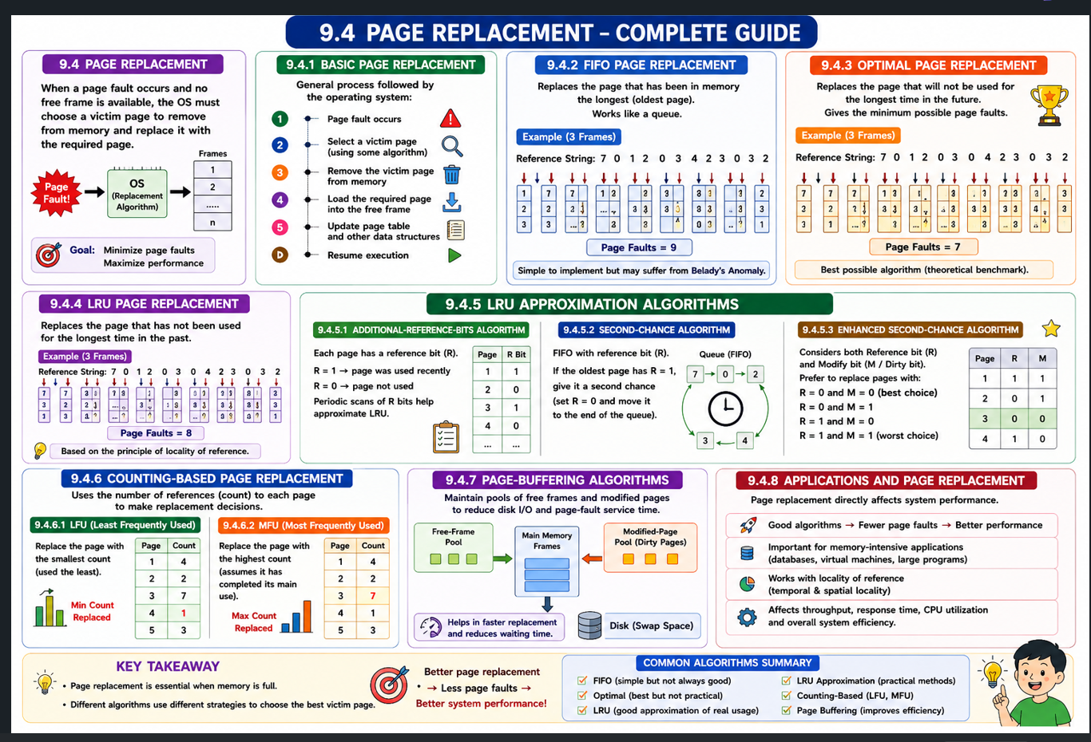

9.4 Page Replacement
Demand paging improves memory utilization because only the pages that are actually needed are loaded into memory. For example, if a process contains 10 pages but normally uses only 5 pages, the operating system loads only those 5 pages. The remaining pages stay on disk, saving memory and allowing more processes to run simultaneously.
This advantage increases the degree of multiprogramming, meaning more processes can be kept in memory at the same time. For instance, if each process requires only 5 active pages instead of 10, a system with 40 frames can support more processes, resulting in better CPU utilization and higher throughput.
However, a problem arises when several processes suddenly need more pages than expected. Suppose six processes are running, each using only five pages initially. If all six processes suddenly require their full ten pages, the total memory demand becomes 60 frames, even though only 40 frames are available. This situation is known as memory over-allocation.
Another challenge is that physical memory is not used only for program pages. The operating system must also allocate memory for I/O buffers, system data structures, and other kernel activities. Therefore, available memory becomes even more limited.
As shown in Figure 9.9, when a process generates a page fault, the operating system locates the required page on disk. However, it may discover that no free frame is available because all frames are already occupied. At this point, the operating system must decide how to obtain a free frame.
One possible solution is to terminate the process, but this is undesirable because virtual memory is designed to make memory management transparent to the user. Another option is to swap out an entire process, freeing all its frames. Although this may be useful in some situations, it reduces the degree of multiprogramming.
The most practical and widely used solution is Page Replacement. In page replacement, the operating system selects a page currently in memory (called the victim page), removes it from memory, and loads the required page into the freed frame. This allows execution to continue even when no free frames are available.
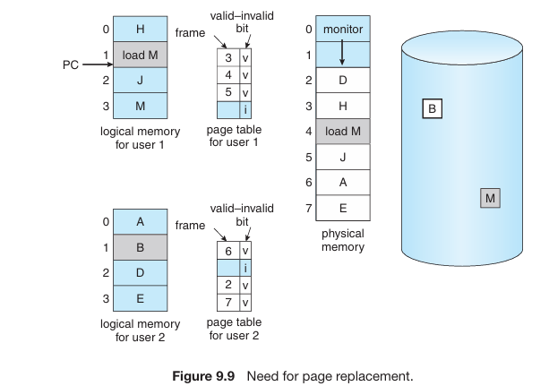

Figure 9.9 explains the need for page replacement. When memory becomes fully occupied and a page fault occurs, the operating system cannot load the required page because no free frame exists. To continue execution efficiently, the operating system selects a victim page, removes it from memory, and loads the required page into the freed frame. This technique is called Page Replacement.
9.4.1 Basic Page Replacement
Page replacement becomes necessary when a page fault occurs and there are no free frames available in physical memory. In such a situation, the operating system cannot simply load the required page into memory because all frames are already occupied. Therefore, the operating system must select an existing page in memory, called the victim page, remove it, and use the freed frame to load the required page. This process is known as Page Replacement.
As shown in Figure 9.10, when a page fault occurs, the operating system first locates the required page on disk. It then checks whether a free frame is available. If a free frame exists, the page is loaded directly into that frame. If no free frame is available, a page-replacement algorithm is used to select a victim page. The selected page is removed from memory, and if necessary, its contents are written back to disk. The required page is then loaded into the newly freed frame, and the page tables are updated. Finally, execution resumes from the point where the page fault occurred.
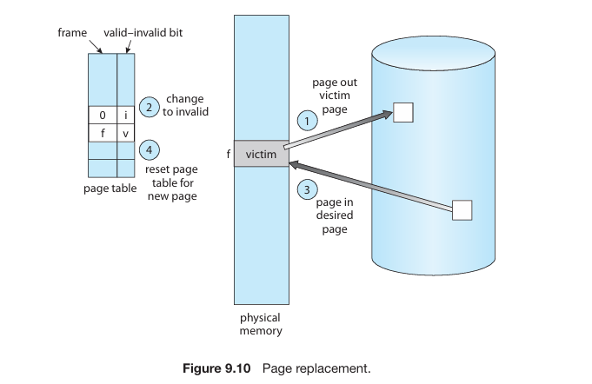

Steps in Page Replacement
- Locate the required page on disk.
- Check for a free frame.
- If no free frame exists, select a victim page.
- Write the victim page to disk if required.
- Load the desired page into the freed frame.
- Update page table and frame table entries.
- Resume process execution.

Problem with Page Replacement
When no free frame is available, two disk operations may be required:
- Page-Out: Write the victim page to disk.
- Page-In: Read the required page from disk.
Victim Page → Disk
Required Page ← Disk
Because disk operations are slow, page-fault service time increases significantly. In fact, requiring both a page-out and page-in operation can nearly double the page-fault handling time.

Solution: Modify Bit (Dirty Bit)
To reduce unnecessary disk writes, operating systems use a Modify Bit (Dirty Bit) associated with each page.
- Dirty Bit = 1
  - Page has been modified.
  - Must be written back to disk before replacement.
- Dirty Bit = 0
  - Page has not been modified.
  - Can simply be discarded.
  - No disk write is needed.
This significantly reduces page-fault service time because many pages do not need to be written back to disk. Read-only pages, such as program code pages, are always clean and can be discarded directly.

Importance of Page Replacement
Page replacement is a fundamental component of Demand Paging. It allows the operating system to execute programs larger than the available physical memory by continuously replacing pages as needed.
For example:
Process Size = 20 Pages
Available Frames = 10
Using page replacement, the process can still execute successfully even though the entire process cannot fit into memory at once. Only the required pages are kept in RAM, while others remain on disk.

Evaluating Page-Replacement Algorithms
Different page-replacement algorithms are compared using a Reference String, which is the sequence of page references generated by a process.
Example:
7, 0, 1, 2, 0, 3, 0, 4, 2, 3, 0, 3, 2, 1, 2, 0, 1, 7, 0, 1
The effectiveness of an algorithm is measured by the number of page faults it produces.
Goal:
- Minimize page faults.
- Minimize disk I/O.
- Improve overall system performance.

🔑 Important Points
✅ Page replacement is needed when a page fault occurs and no free frame exists.
✅ The page selected for removal is called the Victim Page.
✅ Two disk operations may be required:
- Page-Out
- Page-In
✅ Dirty Bit (Modify Bit) reduces unnecessary disk writes.
✅ Dirty Bit = 1 → Write page to disk.
✅ Dirty Bit = 0 → Discard page directly.
✅ Page replacement enables execution of programs larger than RAM.
✅ Performance of page-replacement algorithms is measured using:
- Reference String
- Number of Page Faults

Example 1: Consider page reference string 1, 3, 0, 3, 5, 6, 3 with 3-page frames. Find the number of page faults using FIFO Page Replacement Algorithm.
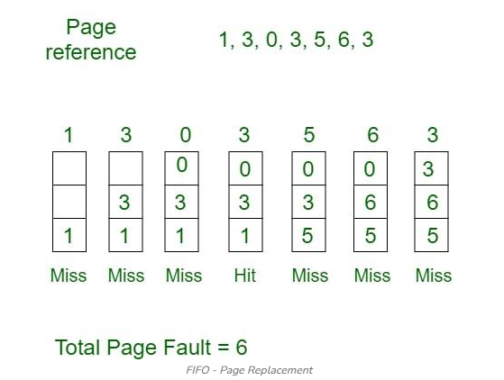
- Initially, all slots are empty, so when 1, 3, 0 came they are allocated to the empty slots ---> 3 Page Faults.
- When 3 comes, it is already in memory so ---> 0 Page Faults.
- Then 5 comes, it is not available in memory, so it replaces the oldest page slot i.e 1. ---> 1 Page Fault.
- 6 comes, it is also not available in memory, so it replaces the oldest page slot i.e 3 ---> 1 Page Fault.
- Finally, when 3 come it is not available, so it replaces 0 1-page fault.

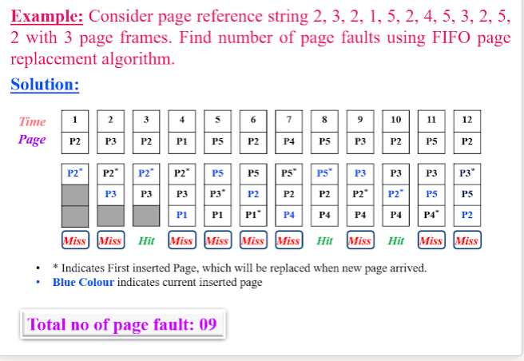

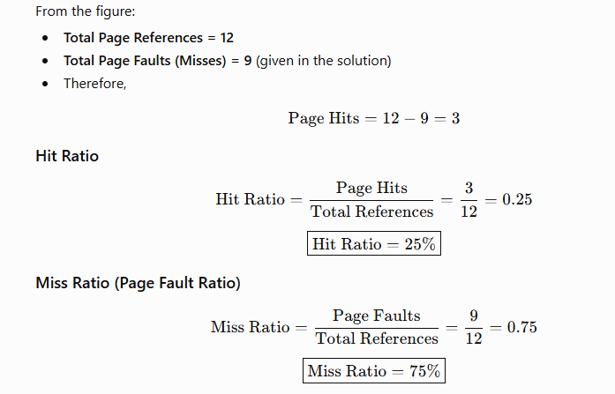

Metric | Value
Total References | 12
Page Faults (Misses) | 9
Page Hits | 3
Hit Ratio | 25%
Miss Ratio | 75%

2. Optimal Page Replacement
In this algorithm, pages are replaced which would not be used for the longest duration of time in the future.
Example: Consider the page references 7, 0, 1, 2, 0, 3, 0, 4, 2, 3, 0, 3, 2, 3 with 4-page frame. Find number of page fault using Optimal Page Replacement Algorithm.
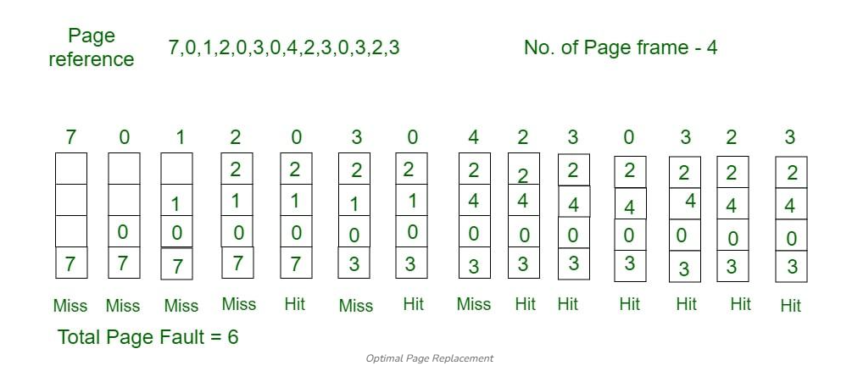
- Initially, all slots are empty, so when 7 0 1 2 are allocated to the empty slots ---> 4 Page faults
- 0 is already there so ---> 0 Page fault. when 3 came it will take the place of 7 because it is not used for the longest duration of time in the future---> 1 Page fault.
- 0 is already there so ---> 0 Page fault. 4 will takes place of 1 ---> 1 Page Fault.
Now for the further page reference string ---> 0 Page fault because they are already available in the memory. Optimal page replacement is perfect, but not possible in practice as the operating system cannot know future requests. The use of Optimal Page replacement is to set up a benchmark so that other replacement algorithms can be analyzed against it.

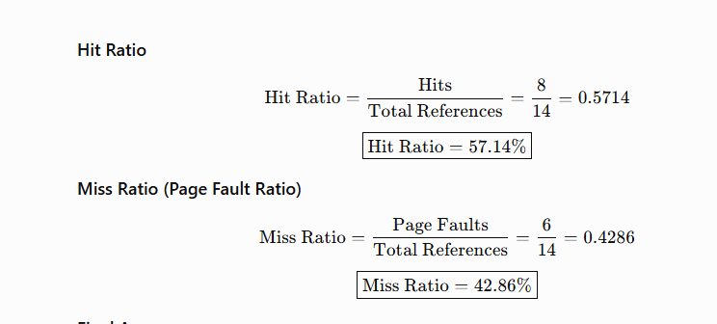
Metric | Value
Page Faults | 6
Page Hits | 8
Hit Ratio | 57.14%
Miss Ratio | 42.86%

3. Least Recently Used
In this algorithm, page will be replaced which is least recently used.
Example Consider the page reference string 7, 0, 1, 2, 0, 3, 0, 4, 2, 3, 0, 3, 2, 3 with 4-page frames. Find number of page faults using LRU Page Replacement Algorithm.

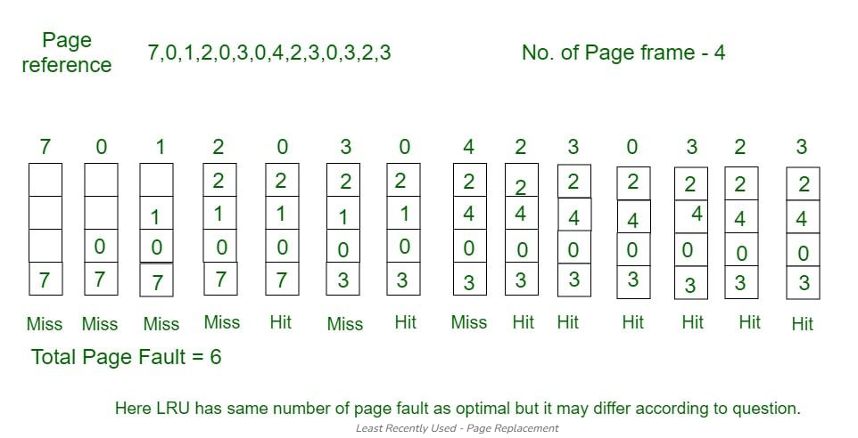
- Initially, all frames are empty. When 1, 3, 0 arrive, they are placed in empty frames, resulting in 3 page faults.
- When 3 arrives again, it is already present in memory, so there is no page fault.
- When 5 arrives, it is not in memory, so it replaces the oldest page (1), resulting in 1 page fault.
- When 6 arrives, it is not in memory, so it replaces the oldest page (3), resulting in 1 page fault.
- Finally, when 3 arrives, it is not in memory, so it replaces the oldest page (0), resulting in 1 page fault.
Total Page Faults = 6

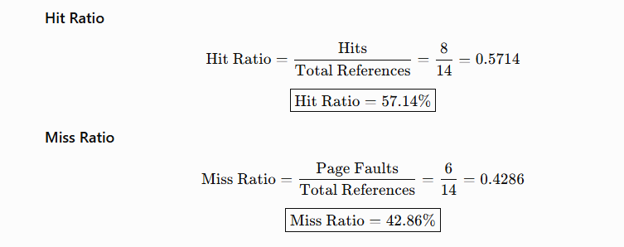

Metric | Value
Page Faults | 6
Page Hits | 8
Hit Ratio | 57.14%
Miss Ratio | 42.86%

Section | Topic | Brief Explanation
9.5 | Allocation of Frames | Defines how available memory frames are distributed among processes.
9.5.1 | Minimum Frames | Minimum number of frames required for process execution.
9.5.2 | Allocation Algorithms | Methods such as equal, proportional, and priority-based frame allocation.
9.5.3 | Global vs Local Allocation | Determines whether frames can be taken from any process or only the current process.
9.5.4 | NUMA | Memory architecture where memory access time depends on processor location.

9.5 Allocation of Frames

Memory allocation for processes involves dividing the available free frames among them. In a single-user system with 93 free frames, the operating system allocates the required frames for system tasks, and the remaining frames are used for the user process. If the user process exceeds the available frames, page replacement occurs. Variations include reserving frames for system tasks or ensuring a few free frames remain available during page swaps.

Minimum Number of Frames
Frame allocation strategies must balance performance and system constraints. We cannot allocate more frames than available, and a minimum number of frames is required for process execution. Allocating too few frames increases the page-fault rate, slowing execution. The minimum number of frames depends on the architecture, considering factors like instruction complexity and indirection levels. The maximum number is constrained by available physical memory, and efficient frame allocation lies between these limits.

9.5.2Allocation Algorithms
In virtual memory management, allocation algorithms are used to manage how memory pages are assigned to physical memory (RAM) and how virtual memory is mapped to it. These algorithms are essential to optimize the use of memory and ensure efficient process execution.

Global versus Local Allocation
Page replacement algorithms can be classified into global replacement and local replacement. In global replacement, a process can select a replacement frame from any process, potentially taking frames from lower-priority processes. Local replacement restricts processes to selecting frames from their own allocation. Global replacement may lead to unpredictable performance due to external factors, while local replacement ensures stability but may limit flexibility. Global replacement often results in better system throughput and is therefore more commonly used.

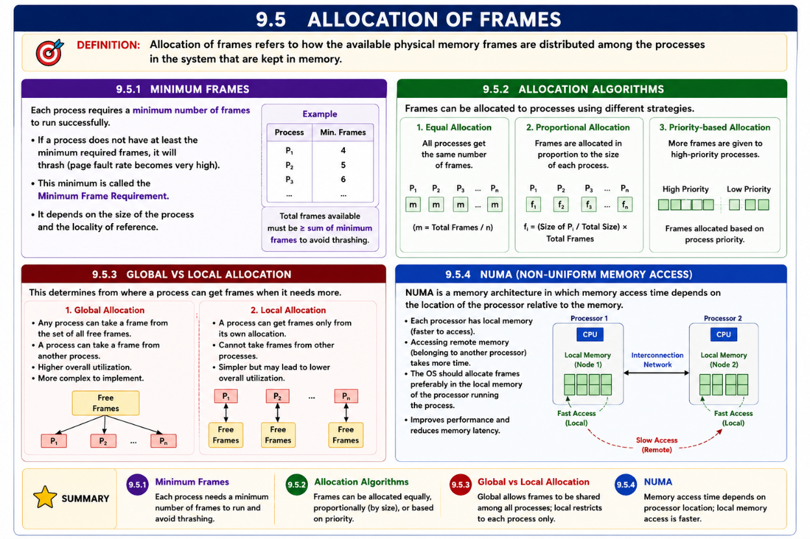
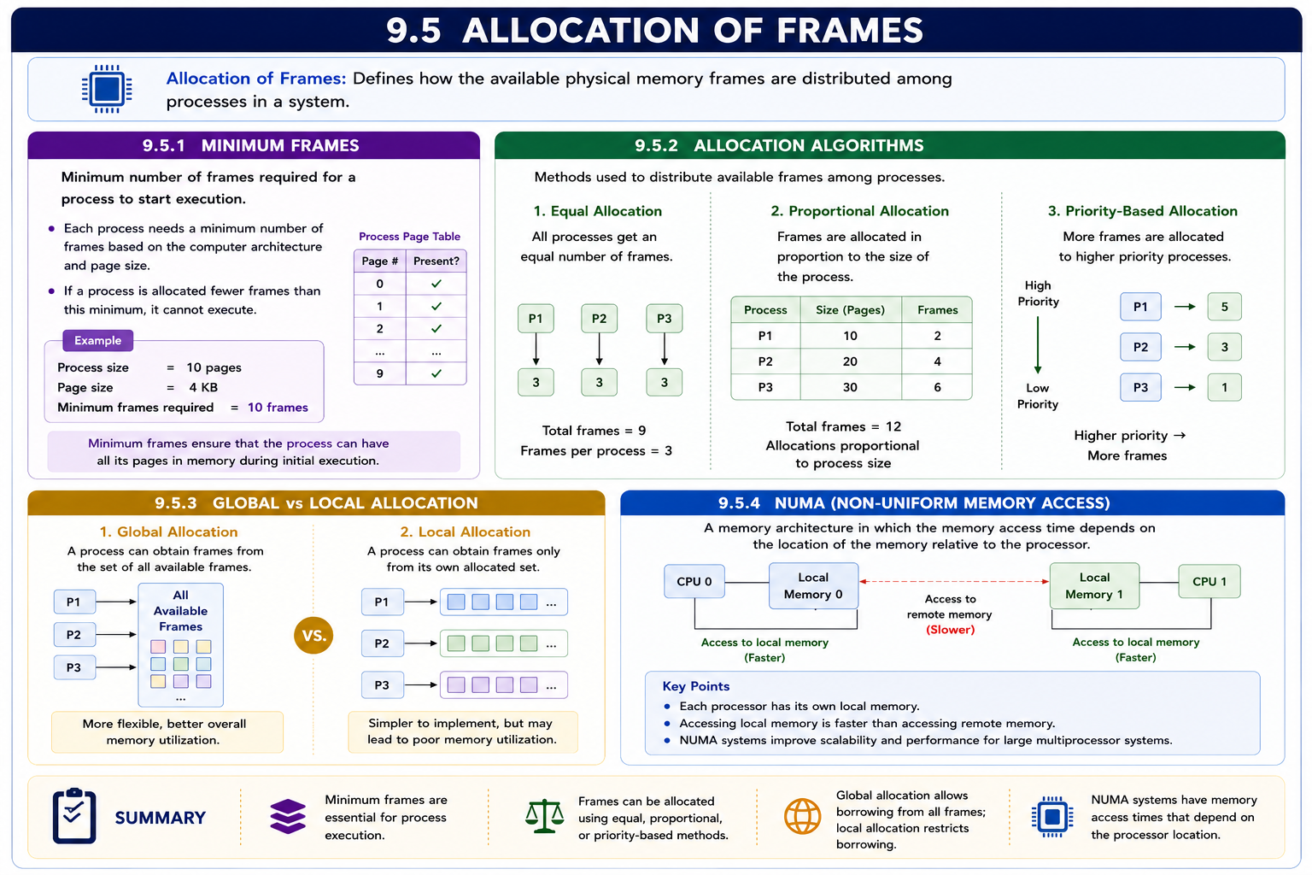
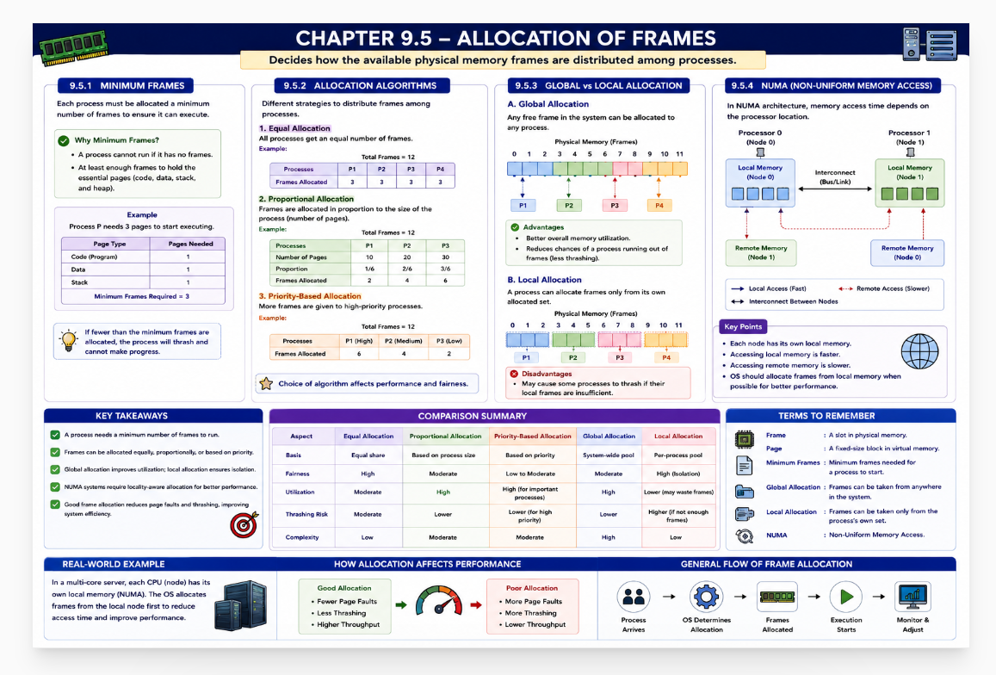
  - Thrashing
If a low-priority process is allocated fewer frames than required, it is suspended, and its pages are swapped out to free frames. This introduces a swap-in, swap-out mechanism. A process with insufficient frames will repeatedly page-fault, replacing pages that are needed immediately, leading to thrashing. Thrashing occurs when a process spends more time paging than executing, severely affecting performance.
Section | Topic | Brief Explanation
9.6 | Thrashing | Condition where excessive page faults cause the system to spend more time paging than executing, leading to severe performance degradation.
9.6.1 | Cause of Thrashing | Occurs when processes are allocated insufficient frames. Frequent page faults force continuous page replacement, reducing CPU utilization and increasing paging activity.
9.6.2 | Working-Set Model | Uses the concept of locality to determine the set of pages actively used by a process. Allocating enough frames for the working set helps prevent thrashing.
9.6.3 | Page-Fault Frequency (PFF) | Controls thrashing by monitoring the page-fault rate. If the fault rate is too high, more frames are allocated; if too low, frames may be removed.
9.6.4 | Concluding Remarks | Thrashing severely impacts system performance. The best solution is to provide sufficient physical memory and use proper frame-allocation strategies such as Working-Set and PFF control.

Cause of Thrashing

Thrashing occurs when a system spends most of its time swapping pages in and out of memory instead of executing processes. This is typically caused by insufficient memory allocation for processes, leading to excessive page faults. When processes do not have enough frames to keep their working set in memory, they continuously replace pages that are immediately needed again.

Example:
Consider two processes, A and B.
      - Process A needs 4 pages, but only 2 frames are allocated.
      - Process B needs 3 pages, but only 2 frames are allocated.
Both processes keep page-faulting as they continuously replace pages that are still in use. This constant swapping causes thrashing, slowing down the system significantly.
9.6.3 Demand Paging and Thrashing
Demand paging loads a page into memory only when it is actually needed by a process. While demand paging improves memory utilization and allows more processes to reside in memory, excessive demand paging can lead to a serious problem called thrashing. Thrashing occurs when a process does not have enough frames allocated to hold its actively used pages, causing frequent page faults. As a result, the operating system spends more time swapping pages between secondary storage and main memory than executing actual user instructions.

During thrashing, CPU utilization decreases because the processor is forced to wait for page transfers instead of performing useful work. The operating system may incorrectly interpret the low CPU utilization as a need to increase the degree of multiprogramming, which further worsens the problem by introducing more competing processes. Therefore, thrashing leads to poor system performance, high page-fault rates, increased disk activity, and reduced throughput. Proper frame allocation and memory-management policies are essential to prevent thrashing and maintain efficient demand paging.

Working-Set Model

The Working-Set Model is a memory management technique that aims to optimize the allocation of frames by ensuring that a process keeps its frequently used pages in memory. The "working set" refers to the set of pages that a process is actively using within a given time window. The goal is to keep this working set in memory to reduce page faults and improve performance.

Example:
Consider a process with 10 pages. If the time window (or working-set window) is set to 3 pages, the system will track the 3 most recently used pages at any given time. As the process accesses pages, it will load the pages within the working set into memory and evict less frequently used pages. This way, the process minimizes page faults by keeping its actively used pages in memory.
This model helps prevent thrashing by adjusting the number of pages allocated based on the process’s actual usage pattern.

Page-Fault Frequency
The Page-Fault Frequency (PFF) algorithm is a memory management technique used to adjust the number of pages allocated to a process based on its page fault rate. If a process experiences too many page faults, it is allocated more frames; if page faults are low, it may have some frames taken away. The idea is to keep the page fault rate within an acceptable range for efficient execution.

Example:
Consider a process with 4 frames allocated:
      - If the page fault rate exceeds a threshold (e.g., more than 1 page fault every 10 ms), the system allocates an additional frame to the process.
      - If the page fault rate is low (e.g., less than 1 page fault every 10 ms), it may reduce the number of frames allocated to the process.
This dynamic adjustment helps optimize memory usage and performance by maintaining an appropriate balance between memory allocation and page faults.
